ASLI ÖRNEK  Örnek Sok. No. 1 Ortaköy - Beşiktaş / İSTANBUL  GSM: (532) 1111111 - Home: (212) 3333333  asliornek@gmail.com | 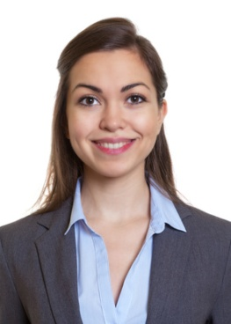
PERSONAL INFORMATION
Date of Birth : 01/01/1993
Nationality : Turkish
Marital Status : Single
Sex : Female
Driving License : B (2014)

EDUCATION
Postgraduate Koç University / Accounting and Finance Management 09/2014 - 06/2016
University Marmara University / Economy 09/2010 - 06/2014
High School Beşiktaş Anatolian High School 09/2006 - 06/2010

WORK EXPERIENCE
ABC Danışmanlık A.Ş. / İstanbul 04/2017 - Working
Accounting Specialist
Preparing the payrolls of the employers. Integrating Netsis software. Increasing the efficiency of the accounting operations by 10%.

XYZ Mali Müşavirlik Ltd. Şti. / Ankara 07/2013 - 09/2013
Intern
Entering the invoices into the system. Experiencing Netsis software. Following up the office operations.

ADDITIONAL EDUCATION & CERTIFICATES
Computerized Accounting Training Ankara University Continuing Education Center 2012
Cost Accounting Certificate Etik Education Center 2011

COMPUTER SKILLS
Word, Excel, Powerpoint, Outlook: Excellent
Netsis: Good

LANGUAGE SKILLS
English Reading: Advanced, Writing: Advanced, Speaking: Good
French Reading: Good, Writing: Good, Speaking: Intermediate

SOCIAL ACTIVITIES
Photography, University Volleyball Team Captain

CLUB & ASSOCIATION MEMBERSHIPS
Member of Marmara University Alumni, TEMA Youth Member, Photography Association Member

REFERENCES
Ayşe Örnek ABC Danışmanlık A.Ş General Manager (212) 9999999
Ahmet Örnek Marmara University Professor (212) 3333333

